Dis-Mex-Precolumbian Female figurine with Headband, Necklace, Earspools, wrist disks

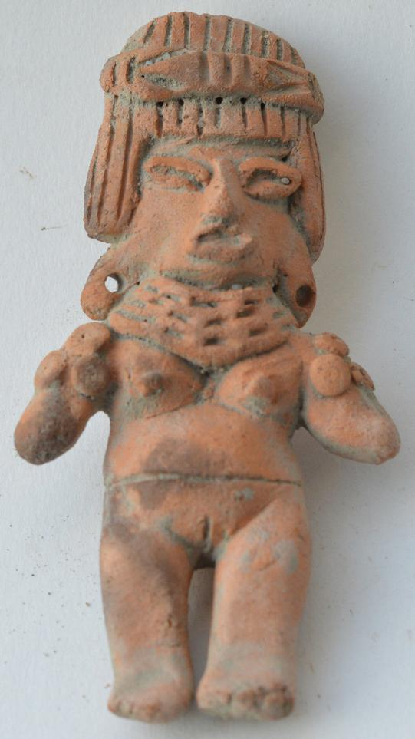 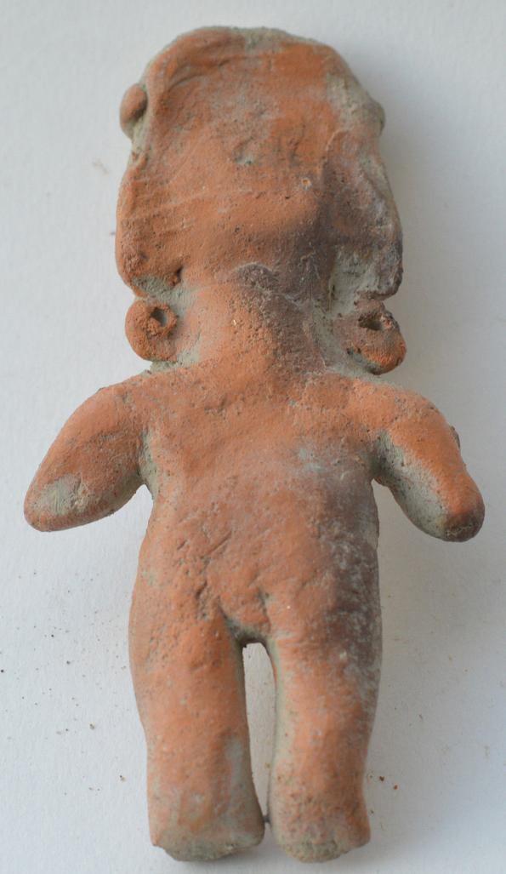

Formal Label: Precolumbian Female figurine with Headband, Necklace, Earspools, wrist disks

Accession Number:

Date or Time Horizon: 500-1500 AD

Geographical Area: Mexico

Cultural Affiliation: Unknown

Medium: Terracotta

Dimensions: H 10 cm

Weight:

Provenance: